Match the photo with the correct country.

1. 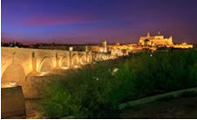 Cordoba bridge and the Mesquita mosque
2. Spain
3. Italy
4. Poland
5. Romania

Answer: a

1. 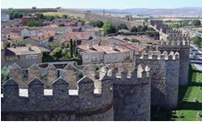 Fortifications of Avila
2. Italy
3. Spain
4. Poland
5. Turkey

Answer: b

1. 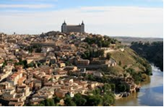 The town and palace fortress of Toledo
2. Spain
3. Turkey
4. Poland
5. Italy

Answer: a

1. 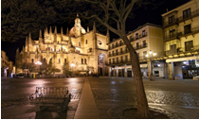 Segovia Cathedral
2. Poland
3. Italy
4. Romania
5. Spain

Answer: d

1. 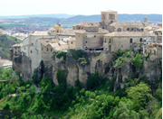 View of Los Canonigos,Cuenca
2. Italy
3. Spain
4. Romania
5. Turkey

Answer: b